**Year1**

**Report-Project1**

***SMART STICK GUIDE FOR DEAFBLIND***

|  |  |
| --- | --- |
| ***Team N: 07***  ***Team Name: Lets Help People*** |  |

Submitted by:

Komiljonov Bobur U1910275(19-03)

Kholmurodov Dilshod U1910232(19-03)

Naimov Fayyoz U1910071(19-02)

Mirsagatova Sitora U1910245(19-03)

Zaynobiddinova Zebiniso U1910278(19-03)

**School of Computers and Information Engineering**



Total word count : 2045

ABSTRACT

This report form is about Smart Stick Guide for Deafblind which was created on the purpose of helping disabled people.

This device is not available in the global market; it has several special conveniences. It assists a lot people who cannot see and hear while walking. Besides, it has some comforts for relatives of deafblind.

CONTENTS

ABSTRACT………………………………………………………………………………………………………………………………2

CONTENTS………………………………………………………………………………………………………………………………2

Introduction……………………………………………………………………………………………………………………2

Background…………………………………………………………………………………………………………………………3

New Developments and Principals Achieved…………………………………………4

Structure of report…………………………………………………………………………………………………5

Gantt Chart………………………………………………………………………………………………………………………6

Survey Results………………………………………………………………………………………………………………6

Design Variables…………………………………………………………………………………………………………7

Quality Function Deployment……………………………………………………………………………8

Conceptual Design Project Flow……………………………………………………………………9

Evaluation and Analysis………………………………………………………………………………………9

Decision-Making Matrix…………………………………………………………………………………………12

Final Design……………………………………………………………………………………………………………………13

Conclusion…………………………………………………………………………………………………………………………15

INTRODUCTION

SMART STICK GUIDE FOR DEAFBLIND helps to individuals who cannot see and hear to walk without fear of falling or bumping into objects around them.

There will be a small camera which observes obstacles. Considering that deafblinds’ sense of feeling is stronger than healthy people, vibration is used to inform disabled about obstacles. Additionally, this stick consists of legs with some special functions.

Till today several tools have been created for deaf and blind to ease their life, but there is no multifunctional device deafblind. Most of the created tools are simple and cannot assist them as much as they expected.

Smart Stick Guide for Deafblind can address to problems of deafblind

BACKGROUND

Before talking about our new version of product, I want to tell about different type of sticks for deafblind people which have already existed in global shops. For example, simple stick, white cane, which is used by many people who are blind or deaf. A white cane primarily allows its user to scan their surroundings for obstacles or orientation and it is designed primarily as a mobility tool used to detect objects in the path of a user. A cane is well-known around Europe countries like UK, British and etc. Since it is so heavy to carry around walking as well as it is easy to make it shorter or small. But it hasn’t any additional features to make users, deafblind, comfort in a walking path. Then, we inspired from self-guide stick, which comprises a crutch body and a handle, characterized in that: one end of the handle, install rotary needle orientation, when an obstacle is encountered, the walking stick vibration occurs at the same time, the deaf can according to the direction of rotation by rotating needle in the thumb down, immediately know traffic direction of security; secondly, the handle side end is provided with a pop-up rounded rectangle button, at the traffic light, would immediately pop up, playing the four fingers touch the deaf blind, when the lights are green, we will immediately restore. But, when you look to this stick, you can understand easily that it has also one feature to use, actually this is one of the vital features to walk in a path. Because, more car crashesare being in deafblind people life within not to knowing whether traffic light is red or blue. In the process of research, we found also one of the stick which is generation of smart sticks, the eye stick, which has Sonic vibrations provide one of the most accurate ways for the visually impaired to get their bearings in an environment, so equipping the end of a walking stick with a little sensor can instill confidence even when dealing with stairs and other potentially dangerous scenarios. So, we just discussed these 3 products pros & cons and we added feature, changed design and make a user to feel fully-confidence while using this stick. When you see several canes or sticks which have already had in global market, each of them has its different disadvantages because they aren’t fully-finished. We decided to create the stick which combine several features, make fully-confident atmosphere around user and make convincing itself, carry easily in the walking, not to worry in dangerous situations and the most important is to giving them light in their life. Maybe that’s why we named it “our magic product”.

We hope that this stick won’t be looks like other type of canes. Because we didn’t try to give users stick, we just tried to give them their expected eyes and ears.

New Developments and Principal Results Achieved

Everyone knows that, there are already different kinds of walking sticks in the market today. The walking sticks have been being commonly used by the old, disabled people (a person who has some difficulties in walking or a person who has not eyesight). With the help of some researches, we found out that, the main disadvantage of current walking sticks is it has limited functions. However, in todays developing world every tool must be multi-functional and user-friendly.

On the other hand, the conceptual design that we have made, has more than 1 functions. It doesn’t only help disabled people to walk properly, but also it helps them to identify which direction they should go. If in front of walking stick, any obstacle is recognized, smart sensors of walking stick will inform the user about it.

Moreover, it is known that there is not such walking stick that can be used by both deaf and blind people. If a person has a disability in both hearing and seeing, he/she cannot use ordinary walking sticks. But our conceptual design is very appropriate tool for them. Due to the special tool, that the users wear on their wrists, the users get vibrations to which direction to go.

Taking into account the real-life situations, we have added a feature that helps the users how to act on traffic lights. The conceptual design has a camera and it identifies the colors of traffic lights. If it is green, it tells the user to move, and vice versa happens if the color is red.

The main feature that should be mentioned in our conceptual design is the FOUR legs of walking stick. These legs regulate themselves on any surface. The main reason for this is it works because of water pressure.

Structure of Report

In this report the steps of the conceptual designing process will be given in the following order:

1. Gantt Chart
2. Survey Results: Customer Complaints and Requirements
3. Design Variables
4. Quality Function Deployment (QFD)
5. Conceptual Design Project Flow
6. Evaluation and Analysis
7. Decision-Making Matrix
8. Final Design

GANTT CHART

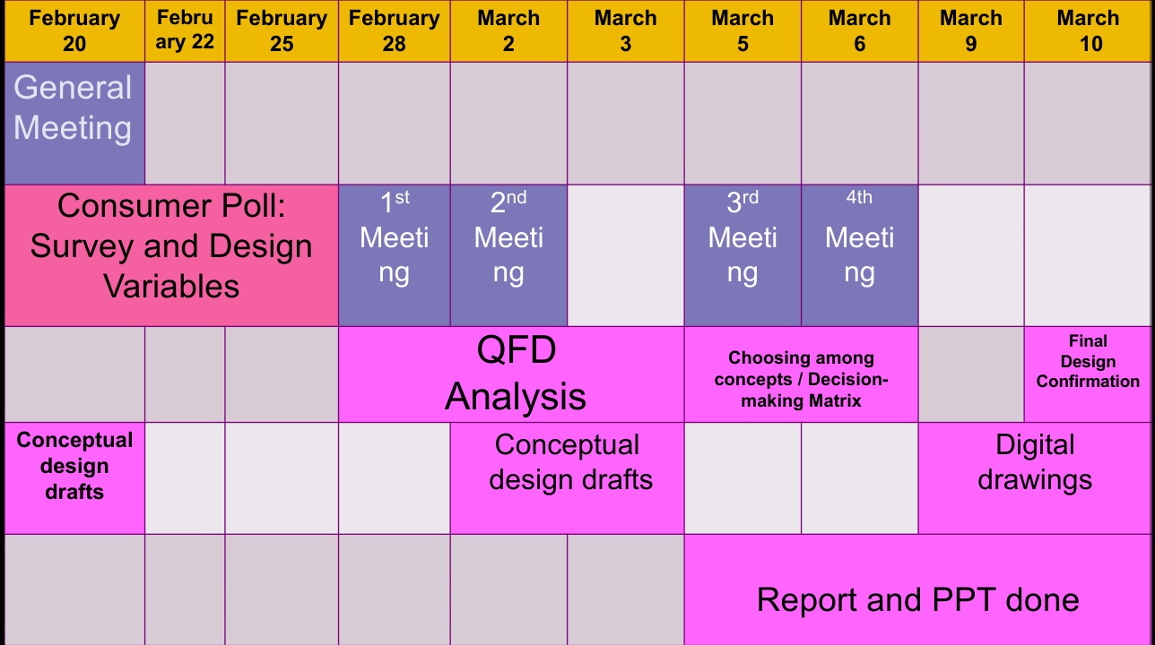

Conceptual Designing Process lasted 20 days, in which 4 Meetings and one General Meeting was held.

SURVEY RESULTS

Customer Complaints:

* Available stick guides are difficult to use
* Current devices are not well-suited for walking
* The range of functionality very narrow
* Not so affordable for poor
* Not suitable for different weather conditions
* Can be broken easily
* Smart devices consume much energy
* Stick guides are heavy to carry
* Do not have attractive design

Customer Requirements:

* Want something easy to use(C1)
* Want something that do not disturb while walking(C2)
* Want something with more than 1-2 functions(C3)
* Want something cheap to purchase(C4)
* Want something that can be used in different weather conditions(C5)
* Want something durable (C6)
* Want something that do not consume much energy(C7)
* Want something light to carry always (C8)
* Want something with beautiful design(C9)

The most obvious solutions to the problems:

* To create a stick that is not so complicated(C1)
* To think about design that is suitable to carry and use(C2)
* To add some new functions(C3)
* To use materials that are not expensive(C4)
* To create in a design which is suitable for different weather conditions(C5)
* To use durable materials like aluminum(C6)
* To use long lasting batteries(C7)
* To make the stick guide as light as possible(C8)
* To create a stick with attractive design(C9)

DESIGN VARIABLES

1. Easy to use: user should not get confused while using

2. Does not disturb normal walking: device should not hinder normal working

3. Multifunctioning: new features should be added and existing ones improved

4. Cost: added features should maintain cost

5. Safety: users should feel safe while using

6. Durable: stick should be usable for a long time

7. Energy consumption: it should utilize less energy

8. Light weight: stick must not be heavy to carry

9. Design: stick should be convenient to use in unique design

Customer Requirements:

* Want something easy to use(C1)
* Want something that do not disturb while walking(C2)
* Want something with more than 1-2 functions(C3)
* Want something cheap to purchase(C4)
* Want something that can be used in different weather conditions(C5)
* Want something durable(C6)
* Want something that do not consume much energy(C7)
* Want something with beautiful design(C9)

Quality Function Deployment

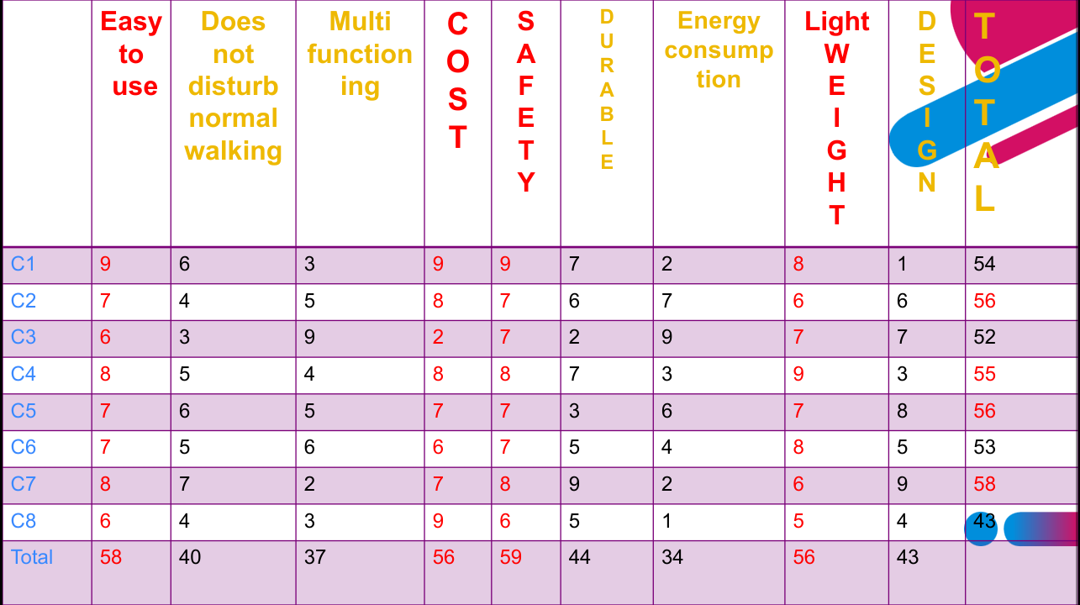

The QFD shows that several features and functions, including comfortableness to use, affordable cost, safety, and weight are considered as the important functions that should be added and improved.

CONCEPTUAL DESIGN PROJECT FLOW

At the beginning of project, when our team decided to invent something new for deafblind, we knew that being informed about obstacles around them is one the major problems of deafblind.

We decided to use a deaf blind guide as a base. In order to solve the problem our team decided to add a mini camera which can observe obstacles around.

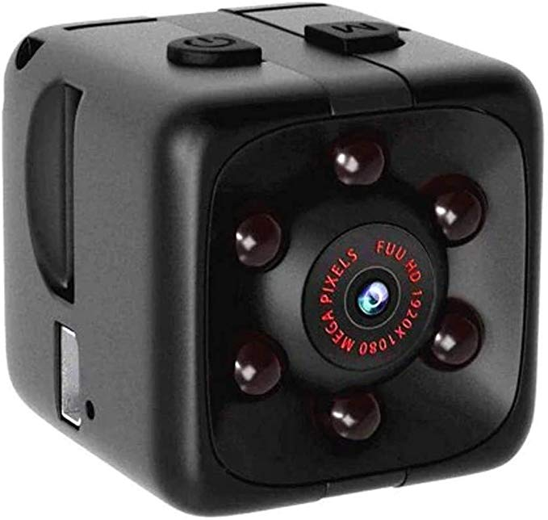 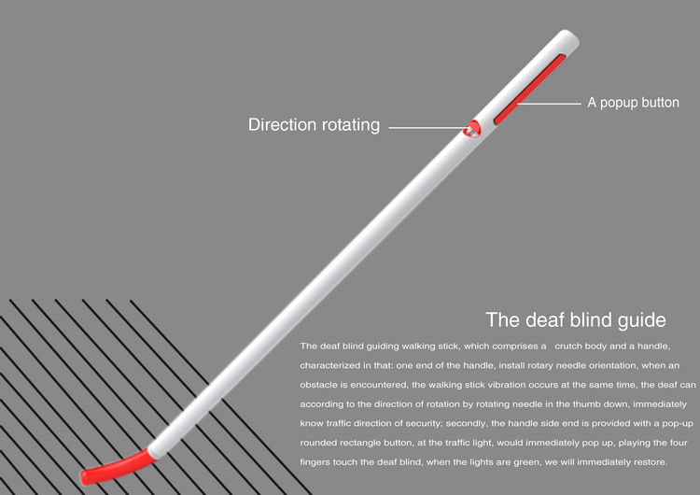

The deafblind guide

The deaf blind guide has a vibrating function itself. When camera observes obstacles it sends signal to holding part (to the top) where vibration system was installed.

Additionally, after survey we found that relatives of deafblind always feel worried of them. To solve this issue we decided to add GPS. This GPS always informs to relatives where the consumer is. Also, it decreases rate of losing stick guides.

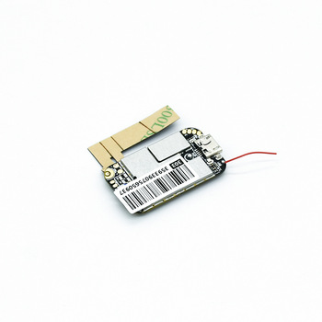 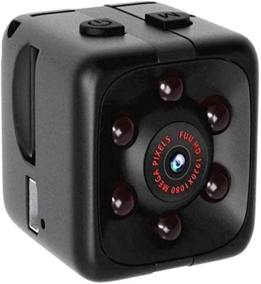 

GPS Mini camera The deaf blind guide

Also we found that, existing guide sticks are not so safe. It cannot stop people from falling down. Adding four legs to the stick was our solution to the mentioned problem.

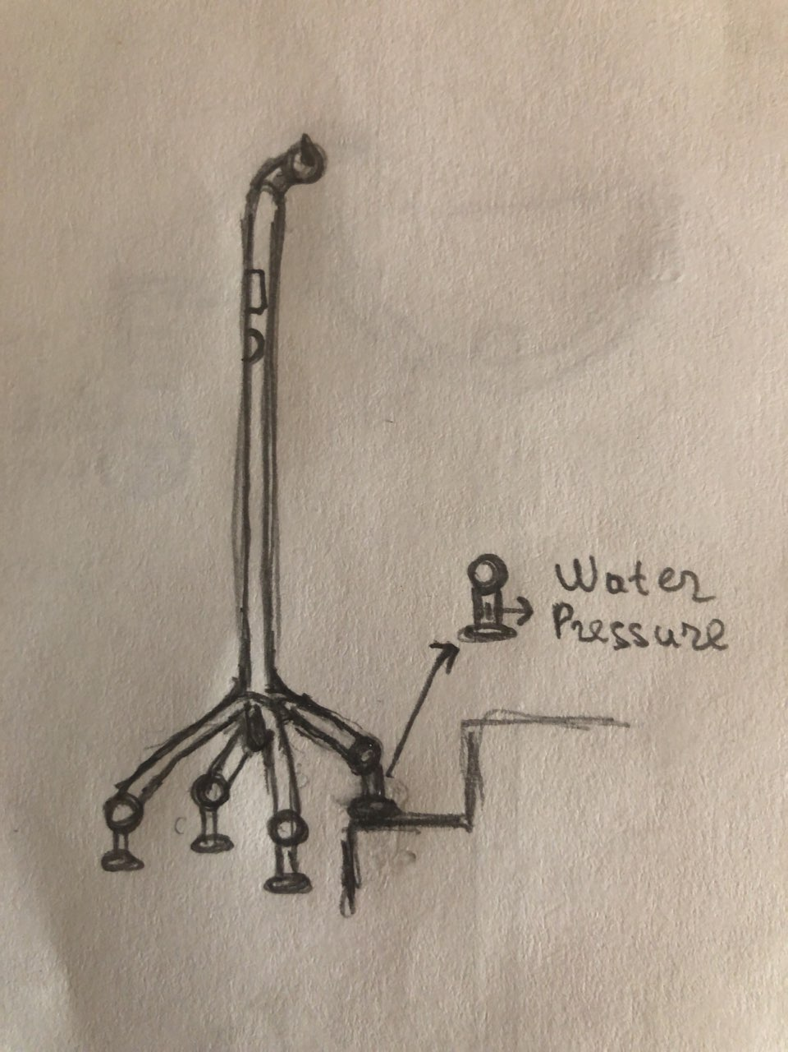

We tried to use biomimicry here to form the idea of legs to stick and to stabilize it. That four legs can adapt the surface itself like dragonfly’s legs.

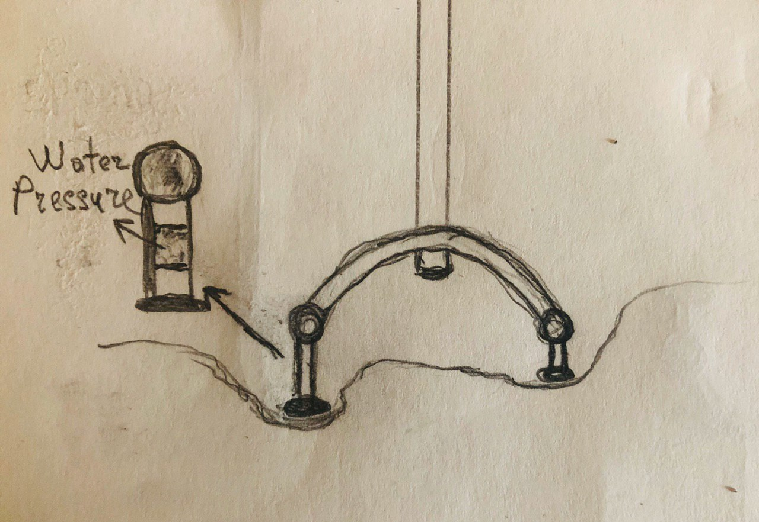

As mentioned above these four legs help to walk in different weather conditions including freezing weather. There are torns on the bottom surface of legs which can be controlled with pressing only one button

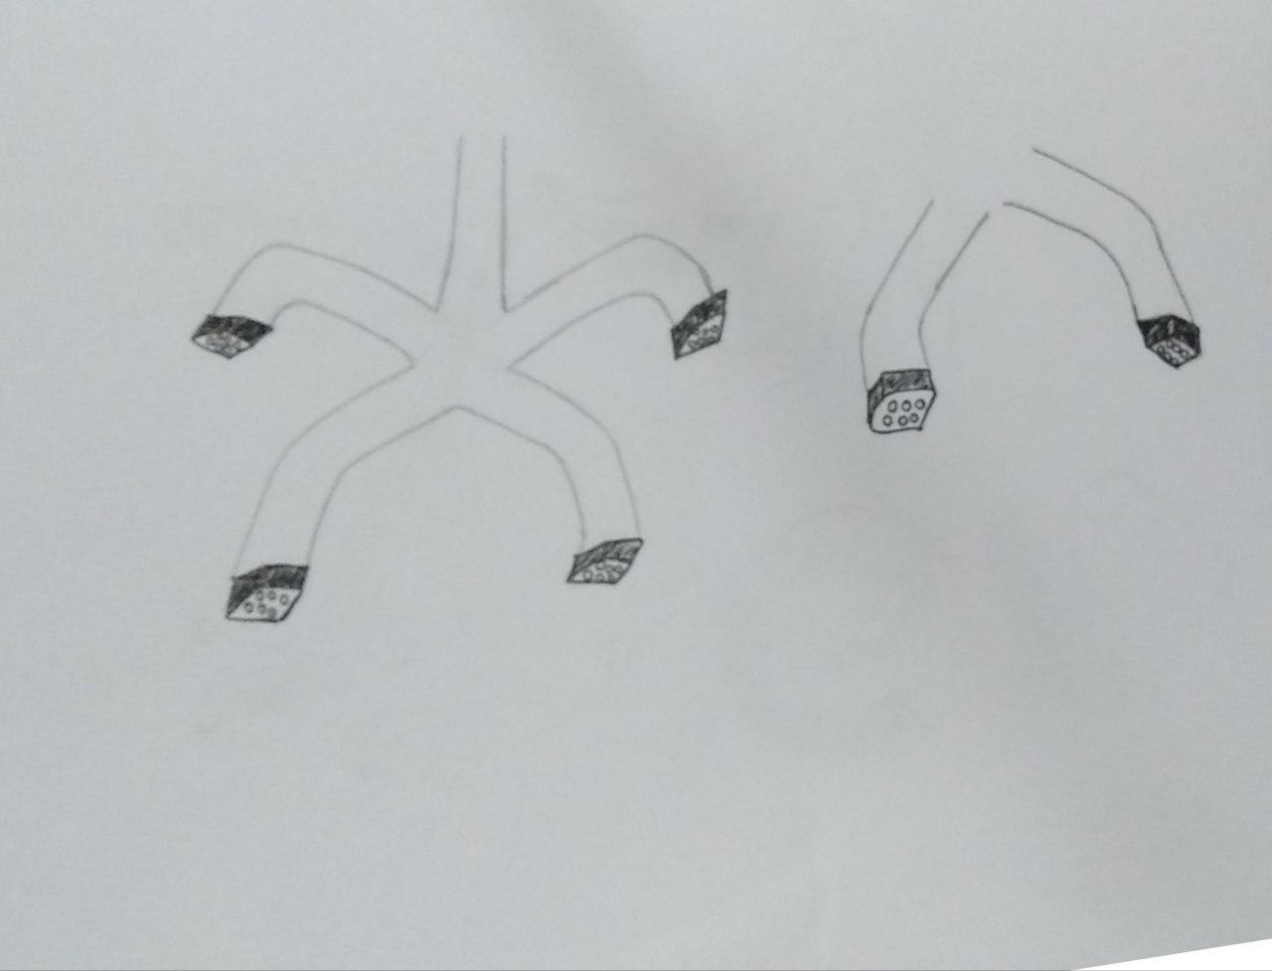

Finally we wanted to change the holding part too. Reason for this is that deafblind cannot find the stick themselves if they unexpectedly throw it.

The team has selected the way of developing these features in the above-mentioned way.

EVALUATION and ANALYSIS

1. Easy to use: Positive Effect. Stick is very comfortable to use

2. Does not disturb normal walking: Positive Effect. It was created in a very convenient design, there is nothing disturbing.

3. Multifunctioning: Positive Effect. Our product has a camera, GPS, legs, torn and different holding part.

4. Cost: Negative Effect. Cost is expected to rise due to new features.

5. Safety: Positive Effect. Legs keep users from falling.

6. Durable: Positive Effect. Our product will be durable because of the materials used.

7. Energy consumption: No Effect.

8. Light weight: Positive Effect. Stick will not be so heavy even though several features were added.

9. Design: Positive Effect. Our product will be in a unique design.

DECISION MAKING MATRIX



FINAL DESIGN

The final product is Smart Stick Guide for Deafblind that was created on the purpose of helping disabled people. The product has a camera which sends signal, a GPS that always informs about users place, legs that help to keep stability, torns that gives chance to walk in different weather conditions and finally another holding part with completely different des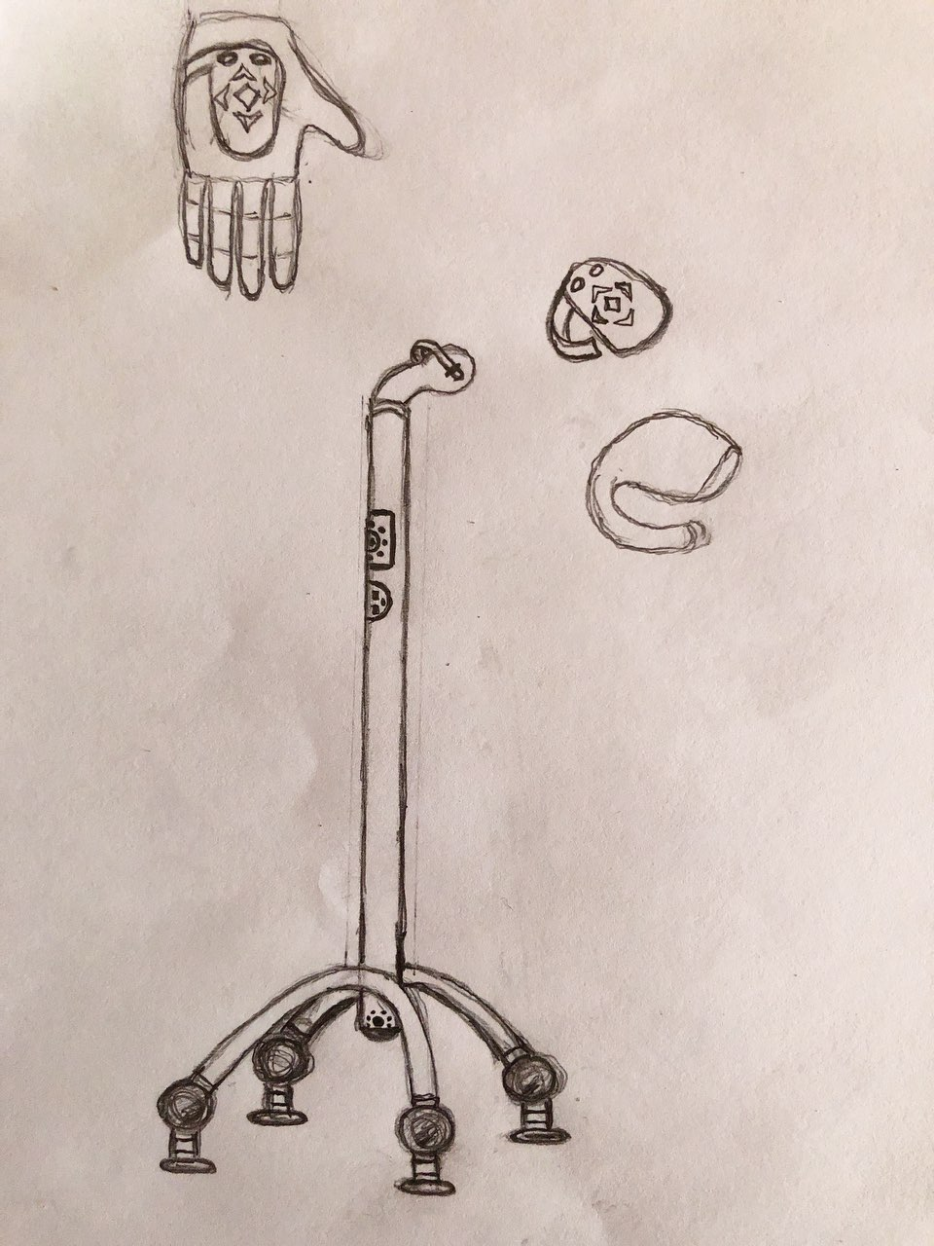 Final design of the product

CONCLUSION

In this Conceptual Design Project team “ Let’s Help People” tried to modify existing stick guides for deafblind.

As a result team developed conceptual design of stick guides which is not available in the global market.

The product is considerably helpful for disabled who always face to difficulties in normal walking. Moreover, our product is not specialized for deafblind only, people who are either deaf or blind can also enjoy using it as well.